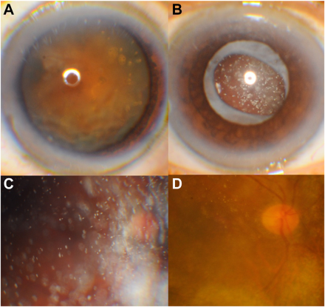

A 66-year-old man, diagnosed with phacolytic glaucoma, had visual acuity (VA) of light perception, iridescent opacities in the anteriorchamber (AC), dense cataract (A), and elevated intraocular pressure in the right eye. One week after cataract surgery, his VA was handmotion. Iridescent crystals were noted behind the intact posterior capsule in the vitreous. (B) Fundus examination showed "snowflake"opacities in the vitreous, obscuring the details of the retina. (C) Twelve weeks later, VA improved to 20/50 and the opacities in the vitreouswere noted to have decreased. Based on the provided images and clinical description please make an ophthalmic diagnosis for this patient. And output the diagnostic conclusions only.

**Vitreous cholesterolosis**